**KENSRI SCHOOL & COLLEGE**



**PROJECT REPORT ON**

**SPYONIC**

**DONE BY,**

*M. UDAY KIRAN, XII*

*NIDHIN MANNOHARAN, XII*

*FARHA TABASSUM.R, XII*

**UNDER THE GUIDANCE OF,**

*RAVISHANKAR G.*

**Computer Science (083)**

**_____________________________________________________________________**

In partial fulfillment of the requirement

for the award of the class of

CBSE FOR AISSCE 2021-22

***Index***

* SYNOPSIS
* CERTIFICATE
* DECLARATION
* ACKNOWLEDGEMENT
* INTRODUCTION
* SYNOPSIS
* PROJECT DESCRIPTION
* SYSTEM CONFIGURATION
* CODING
* OUTPUT
* BIBLIOGRAPHY



**KENSRI SCHOOL & COLLEGE**

***CERTIFICATE***

This is to certify that M. UDAY KIRAN a student of class XII Science of KENSRI School & College, has successfully completed the Investigatory Project entitled:

**SPYONIC**

He has submitted the above-mentioned project under the guidance of **MR. RAVISHANKAR G** during the year 2021-22 in the partial fulfilment of the **COMPUTER SCIENCE** Practical Examination conducted under AISSCE (All India Senior School Certificate Examination) by CBSE.

**Date:**

**Registration Number:**

|  |  |  |
| --- | --- | --- |
| **Signature of**  **Principal** | **Signature of Subject Teacher** | **Signature of**  **External Examiner** |



**KENSRI SCHOOL & COLLEGE**

***CERTIFICATE***

This is to certify that NIDHIN MANOHARAN a student of class XII Science of KENSRI School & College, has successfully completed the Investigatory Project entitled:

**SPYNONIC**

He has submitted the above-mentioned project under the guidance of **MR. RAVISHANKAR G** during the year 2021-22 in the partial fulfilment of the **COMPUTER SCIENCE** Practical Examination conducted under AISSCE (All India Senior School Certificate Examination) by CBSE.

**Date:**

**Registration Number:**

|  |  |  |
| --- | --- | --- |
| **Signature of**  **Principal** | **Signature of Subject Teacher** | **Signature of**  **External Examiner** |



**KENSRI SCHOOL & COLLEGE**

***CERTIFICATE***

This is to certify that FARHA TABASSUM.R a student of class XII Science of KENSRI School & College, has successfully completed the Investigatory Project entitled:

**SPYONIC**

She has submitted the above-mentioned project under the guidance of **MR. RAVISHANKAR G** during the year 2021-22 in the partial fulfilment of the **COMPUTER SCIENCE** Practical Examination conducted under AISSCE (All India Senior School Certificate Examination) by CBSE.

**Date:**

**Registration Number:**

|  |  |  |
| --- | --- | --- |
| **Signature of**  **Principal** | **Signature of Subject Teacher** | **Signature of**  **External Examiner** |



**KENSRI SCHOOL & COLLEGE**

***CERTIFICATE***

This is to certify that UDAY KIRAN, NIDHIN MANOHARAN **&** FARHA TABASSUM. R are students of class XII Science of KENSRI School & College, has successfully completed the Investigatory Project entitled:

**SPYONIC**

He has submitted the above-mentioned project under the guidance of **MR. RAVISHANKAR G** during the year 2021-22 in the partial fulfilment of the **COMPUTER SCIENCE** Practical Examination conducted under AISSCE (All India Senior School Certificate Examination) by CBSE.

**Date:**

**Registration Number:**

**Registration Number:**

**Registration Number:**

|  |  |  |
| --- | --- | --- |
| **Signature of**  **Principal** | **Signature of Subject Teacher** | **Signature of**  **External Examiner** |

**DECLARATION**

We here by declare that the project entitled “**SPYONIC**”, submitted to **KENSRI School and College, Bengaluru**, for the subject of **COMPUTER SCIENCE**, under the guidance of MR. **RAVISHANKAR G, PGT (CS),** is a record of original work done by us. We further declare that this project record or any part of this has not been submitted elsewhere for any other class.

|  |  |
| --- | --- |
| **Sign**  **Student Name**  **Registration Number** | **Sign**  **Student Name**  **Registration Number** |
| **Sign**  **Student Name**  **Registration Number** | |

**ACKNOWLEDGEMENT**

First and foremost, we praise and adore GOD almighty with gratitude, from the depth of my heart who has been as unfailing source of strength, comfort and inspiration in the completion of this project work also who was the input of this project.

We wish to express my sincere thanks and gratitude to Mrs. Shashikala, Principal, KENSRI School and College, Bengaluru, who has provided us with a well-equipped computer lab for the successful outcome of this project work.

WE wish to express my deep & profound sense of gratitude to our Computer Teacher Mr. Ravishankar G, PGT(CS) for his expert & valuable guidance, support, comments and suggestions towards producing a successful project.

We would also like to acknowledge our friends for their valuable suggestions and helping us in hand will error handling and performance of the program.

**INTRODUCTION**

**PYTHON**

* **Introduction:**
* Python was created by **Guido Van Rossum.**
* The language was released in **February I991.**
* Python got its name from a BBC comedy series from seventies- “**Monty Python’s** Flying Circus”
* Python can be used to follow both Procedural approach and Object-Oriented approach of programming.
* It is free to use.
* Python is based on or influenced with two programming languages:
  + ABC language [replacement of BASIC]
  + Modula-3
* **Features of Python:**
* Easy to use Object oriented language
* Expressive language
* Interpreted Language
* Its completeness
* Cross-platform Language
* Fee and Open source
* **Shortcomings of Python**
* **Lesser libraries –** as compared to other programming languages like C++, java. Net
* **Slow language** – as it is interpreted languages, it executes the program slowly.
* **Weak on Type-binding** – It not pin point on use of a single variable for different data type
* **Variety of Usage / Applications**
* Python is being used in many diverse fields/applications, some of which are:
  + Scripting
  + Web Applications
  + Game Development
  + System Administrations
  + Rapid Prototyping
  + GUI Programs
  + Database Applications.
* **Python (a Computer Language) Limitations**
* **Not the fastest language**
* **Lesser libraries than c, java, Perl.**
* **Not strong on type-binding**
* **Not easily convertible.**
* **Working in Python**
* Before we start working on Python, we need to install Python in our computer. There are multiple distributions available today:
  + A Installation available from www.python.org is called Python installation and comes with python interpreter, Python IDLE (Python GUI) and Pip (package installer)
  + ANACONDA Python distribution is one such highly recommended distribution that comes with preloaded many packages and libraries (NumPy, SciPy, Panda etc)
  + Other Popular IDEs like Spyder, PyCharm, etc. Spyder IDE is available as a part of ANACONDA.
* **Working modes in Python:**
* After Python installation we can start working with python.
* In Python we can work in 2 ways:
  + **Interactive Mode (Immediate Mode)**
  + **Script Mode.**
* Both have their own style of working.
* Interactive mode works like a Command Interpreter as Shell Prompt works in DOS Prompt or Linux.
* (>>>) we can execute any instruction of Python with this.
* We can run a complete program by writing in Script mode.



**SQL**

* **Introduction:**
* Structured Query Language and it helps to make practice on SQL commands which provides immediate results.
* SQL is Structured Query Language, which is a computer language for storing, manipulating and retrieving data stored in relational database.
* SQL is the standard language for Relation Database System.
* All relational database management systems like MySQL, MS Access, and Oracle, Sybase, Informix, and SQL Server use SQL as standard database language.
* SQL is the set of commands that is recognized by all RDBMS.
* The Structured Query Language (SQL) is a language that enables you to create and operate on relational database, which are sets of related information stored in tables.
* The SQL (Structured Query Language) has proved to be a standard language as it allows users to learn one set of command and use it to create, retrieve, alter, and transfer information regardless of whether they are working on a PC, a workstation, a mini, or a mainframe.
* MySQL Database System is a combination of a MySQL server instance and a MySQL database.
* MySQL database system operates using client/server architecture, in which the server runs on the machine containing the databases and clients connect to the server over a network.
* **Why SQL?**
* Allows users to create and drop databases and tables.
* Allows users to describe the data.
* Allows users to define the data in database and manipulate that data.
* Allows users to access data in relational database management systems.
* Allows embedding within other languages using SQL modules, libraries & pre-compilers.
* Allows users to set permissions on tables, procedures, and views.
* **Features of MySQL:**
* **Speed:** If the server hardware is optimal, MySQL runs very fast.
* **Ease to use:** MySQL is a high-performance, relatively simple database system.
* **Cost:** Available free of cost.
* **Query Language Support:** Understands standard based SQL.
* **Portability:** Provides portability as it has been tested with a broad range of different compiler and can work on many different platforms.
* **Data Types:** Provide many data types to support different types of data.
* **Security:** Offers a privilege and password system that is very flexible and secure.
* **Localization:** The server can provide error messages to clients in many languages.
* **Connectivity:** Clients can connect to MySQL Server using several protocols.
* **Client and Tools:** Provides command-line programs such as MySQL dump and sysadmin, and graphical programs such as MySQL Administrator and MySQL Query Browser.
* **Advantages of MySQL:**
* Reliability and performance
* Availability of source
* Cross-Platform support.
* Powerful uncomplicated software
* Integrity
* Authorization

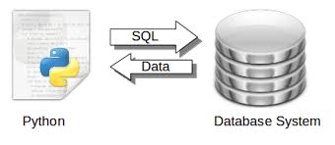**INTERFACE PYTHON WITH MYSQL**

* **Introductions:**
* A database is nothing but an organized collection of data. Data is organized into rows, columns and tables and it is indexed to make it easier to find relevant information
* All companies whether large or small use databases. So it becomes necessary to develop project/software using any programming language like python in such a manner which can interface with such databases which support SQL
* Generalised form of Interface of python with SQL Database can be understood with the help of this diagram.

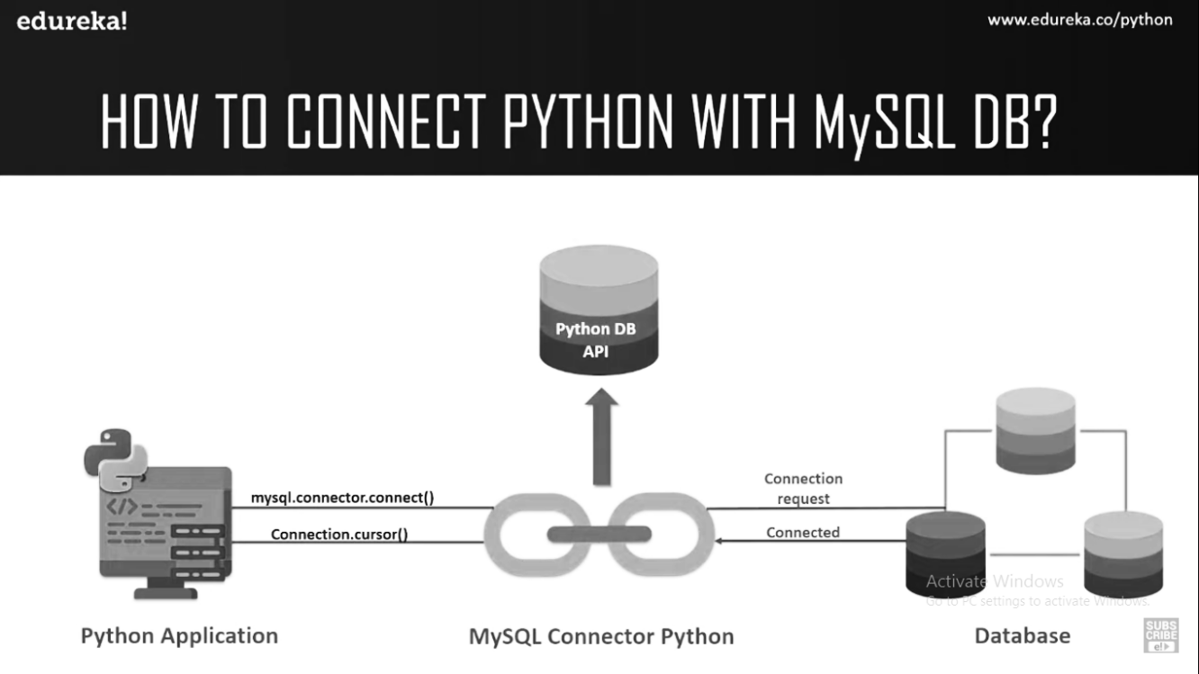

* Form/any user interface designed in any programming language is **Front End** whereas data given by database as response is known as **Back-End database**.
* Using SQL in any of the dbms, databases and table can be **created and data can be accessed, updated and maintained.**
* The Python standard for database interfaces is the Python DB-API. Python Database API supports a wide range of database servers, like **MySQL, MySQL, PostgreSQL, Informix, oracle, Sybase etc.**
* Python allows us to connect all types of database like **Oracle, MySQL, MongoDB, PostgreSQL SQL, SQL Server, DB2** etc.
* **For example**:
  + - Reservation system stores passenger’s details for reserving the seats and later on for sending some messages or for printing tickets etc.
    - In school student details are saved for many reasons like attendance, fee collections, exams, report card etc.
* **Connecting to MySQL from Python**
* Once the connector is installed you are ready to connect your python program to MySQL.
* The following steps to follow while connecting your python program with MySQL
  + - Open python
    - Import the package required (import MySQL. Connector)
    - Open the connection to database
    - Create a cursor instance
    - Execute the query and store it in result set
    - Extract data from result set
    - Clean up the environment

**GUI**

In this project we’ll be using following tools for GUI:

* **HTML**

The Hypertext Markup Language, or HTML is the standard markup language for documents designed to be displayed in a web browser. ... HTML describes the structure of a web page semantically and originally included cues for the appearance of the document. HTML elements are the building blocks of HTML pages.

* **CSS**

CSS stands for Cascading Style Sheets.CSS describes how HTML elements are to be displayed on screen, paper, or in other media.CSS saves a lot of work. It can control the layout of multiple web pages all at once. External stylesheets are stored in CSS files.

* **JAVASCRIPT**

JavaScript is commonly used for creating web pages. It allows us to add dynamic behaviour to the webpage and add special effects to the webpage. On websites, it is mainly used for validation purposes. JavaScript helps us to execute complex actions and also enables the interaction of websites with visitors.

**SYNOPSIS**

# Title of the Project: SPYONIC

# Problem Definition:

# SPYONIC IS A SOFTWARE THAT AIMS to gather information about a person or organization and send it to another entity which stores data. Spyonic uses this data in helping the employer/boss to supervise all employee so when at work, the employee is not misusing data/information about the organization

# Contribution / Team members:

# M. UDAY KIRAN

# NIDHIN MANOHARAN

# FARHA TABASSUM. R

# Team Detail:

# The Project "SPYONIC " is developed by Uday Kiran, Nidhin Manoharan and Farha Tabassum. R. It took approx. 2Months to develop this project, working 1.5 Hours daily. All modules completed by me/us only as per my/our view and knowledge.

# Reason for choosing the Topic:

# Spyonic can be used to protect digital assets of an individual. It allows you to control the online world by keeping a close eye on what is happening, both for personal and professional use. It can be used to track unscrupulous elements. As of personal use, parental control is one of the main reasons for Spyonic. Its ethical use shows user’s online activities, including web history, social media, etc.

# Objective:

# Receive commands like: Shutdown/reboot

# Show Web history

# Show App screentime

# Hardware Requirements

# Quad core processor

# Intel integrated graphics

# Software Requirements:

# Google Chrome

# Microsoft Edge

# Limitations:

# WORKS ONLY ON WINDOWS 10

# References / Bibliography:

# EEL: <https://github.com/ChrisKnott/Eel>

# PSUTIL: <https://psutil.readthedocs.io/en/latest/>